Topic 4.7

AMINES

Preparation of primary, secondary and tertiary amines
Basic properties of amines
Uses of quaternary ammonium salts

PREPARATION OF AMINES

Amines can be prepared in two ways: by nucleophilic substitution of a haloalkane and by reduction from nitriles. The preparation from a haloalkane results in a mixture of primary, secondary and tertiary amines and their salts. The preparation from a nitrile results in the formation of primary amines only.

a) Preparation of amines from haloalkanes

Haloalkanes react with nucleophiles. If ammonia is used as the nucleophile then amines are formed. It is possible to make primary, secondary and tertiary amines and also quaternary ammonium salts by this method, depending on the relative quantities of ammonia and the haloalkane used. It is therefore not considered an effective method for the preparation of primary amines.

The mechanism for the reaction is nucleophilic substitution and it proceeds as follows:


The second step will vary depending on which of the reactants is present in excess.

i) primary amines

If the reaction takes place in excess ammonia, the H will be removed by another ammonia molecule:
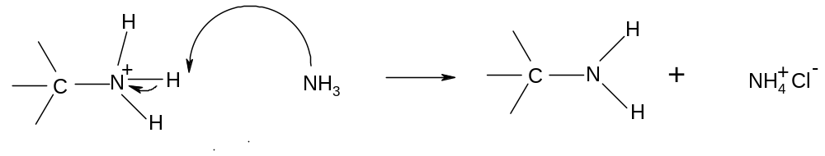
A primary amine is formed and ammonium chloride is the other product.

So primary amines are formed by the addition of excess ammonia to a haloalkane:

R-X + 2NH₃ → R-NH₂ + NH₄⁺X⁻

Eg

Primary amines will also be formed if haloalkanes and ammonia are mixed in a 1:1 ratio. In this case HCl is likely to be the second product as the Cl⁻ will pull off the extra H:
R-X + NH₃ → R-NH₂ + HX

ii) secondary amines

If the reaction takes place in excess haloalkane, the primary amine will attack the remaining haloalkane to form a secondary amine:

So secondary amines are formed by reacting haloalkanes and ammonia in a 2:1 ratio or by reacting a haloalkane with a primary amine in a 1:1 ratio:

2R-X + NH₃ → R-NH-R + 2HX
R₁-X + R₂-NH₂ → R₁-NH-R₂ + HX

Eg

iii) tertiary amines

If any haloalkane is present after the secondary amine has been formed, it can be attacked by the secondary amine to form a tertiary amine:

So tertiary amines are formed by reacting haloalkanes and ammonia in a 3:1 ratio or by reacting a haloalkane with a secondary amine in a 1:1 ratio:

3R-X + NH₃ → R₃N + 3HX
R₁-X + R₂-NH-R₃ → R₁R₂R₃N + HX

Eg

iv) quaternary ammonium salts

If there is any haloalkane left after the tertiary amine has been formed, it will be attacked by the tertiary amine to form a quaternary ammonium salt:

So quaternary ammonium salts can be made by reacting haloalkanes and ammonia in a 4:1 ratio or by reacting tertiary amines and haloalkanes in a 1:1 ratio.

4R-X + NH₃ → [R₄N]⁺X⁻ + 3HX
R₁-X + R₂R₃R₄N → [R₁R₂R₃R₄N]⁺X⁻

Eg 
b) preparation of primary amines from nitriles

Primary amines can be made by treating nitriles with a strong reducing agent such as LiAlH₄:

R-CN + 4[H] → R-CH₂NH₂

Eg CH₃CH₂-CN + 4[H] → CH₃CH₂-CH₂NH₂

Secondary and tertiary amines cannot be prepared in this way; the primary amine is the only product. As a result this preparation produces a very good yield of the primary amine.

BASIC PROPERTIES OF AMINES

Amines are weak bases; the lone pair of electrons on the nitrogen atom can behave as a proton acceptor. The strength of amines varies, but all react with strong acids to make alkylammonium salts.

a) Reaction of amines with acids

Amines react with acids in the same way as ammonia:
NH₃ + HCl → NH₄Cl
2NH₃ + H₂SO₄ → (NH₄)₂SO₄

primary amines: R₁-NH₂ + HCl → R₁-NH₃Cl
2R₁-NH₂ + H₂SO₄ → (R₁-NH₃)₂SO₄
secondary amines: R₁R₂-NH + HCl → R₁R₂-NH₂Cl
2R₁R₂-NH + H₂SO₄ → (R₁R₂-NH₂)₂SO₄
tertiary amines: R₁R₂R₃-N + HCl → R₁R₂R₃-NHCl
2R₁R₂R₃-N + H₂SO₄ → (R₁R₂R₃-NH)₂SO₄

Eg: CH₃NH₂ + HCl → CH₃CH₂NH₃⁺Cl⁻

The charges on the ions are often shown, eg R₁R₂-NH₂⁺Cl⁻

b) Comparison of base strength of different amines

The basicity of ammonia and amines depends on the availability of the lone pair of electrons on the nitrogen atom. The more available the lone pair, the stronger the base.

The availability of the lone pair in turn depends on how much electron density is on the nitrogen atom, and this depends on the adjacent atoms.

Primary amines have one alkyl group attached to the N atom:

The hydrogen atom is slightly more electropositive than the carbon atom. This means that the carbon atom has a slight surplus of electrons which the nitrogen atom can attract towards itself. This effect is known as a “positive inductive effect” and it means that the N atom has an excess of electron density:
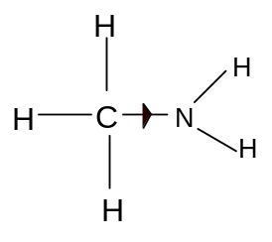
The greater the electron density on the N atom, the more likely the lone pair is to be released for bonding. Primary amines are thus stronger bases than ammonia, as the alkyl groups push electron density onto the N atom, making the lone pair more available for bonding.

It follows that secondary amines, which have two electron-pushing alkyl groups, are stronger bases than primary amines and that tertiary amines are stronger bases than secondary amines.

c) Reaction of alkylammonium salts with bases

The alkylammonium salts are slightly acidic and can be converted back into amines on addition of alkalis:

Primary ammonium salts: R₁-NH₃Cl + NaOH → R₁-NH₂ + NaCl + H₂O
Secondary ammonium salts: R₁R₂-NH₂Cl + NaOH → R₁R₂-NH + NaCl + H₂O
Tertiary ammonium salts: R₁R₂R₃-NHCl + NaOH → R₁R₂R₃-N + NaCl + H₂O

Quaternary ammonium salts are not acidic as the N atom is not bonded to any hydrogen atoms.

USES OF QUATERNARY AMMONIUM SALTS

Quaternary ammonium salts are principally used as cationic surfactants. Long-chain ammonium salts are mainly used for this purpose:

Eg
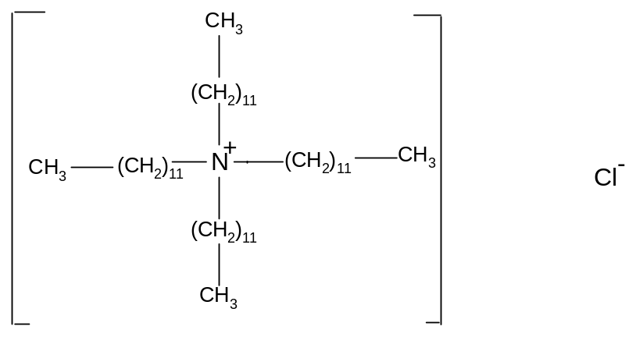
A surfactant is a substance which can be added to a liquid to reduce its surface tension.

Cationic surfactants can also be added to solids which tend to attract negative charge, such as glass, hair and fibres. The cation helps cancel out the negative charge and hence acts as an anti-static agent. This is just one of a variety of functions performed by surfactants.
4. Summary of preparation and acid-base properties of amines

Type of reaction | Mechanism
1. haloalkane → primary amine  reagents: haloalkane and excess ammonia  conditions: heat  equation: R-X + 2NH₃ → R-NH₂ + NH₄X  or  reagent: haloalkane and ammonia (1:1 ratio)  conditions: heat  equation: R-X + NH₃ → R-NH₂ + HX  2. haloalkane → secondary amine  reagents: haloalkane and ammonia (2:1 ratio)  conditions: heat  equation: 2R-X + NH₃ → R-NH-R + 2HX  or  reagents: haloalkane and primary amine  conditions: heat  equation: R₁-X + R₂-NH₂ → R₁-NH-R₂ + HX  3. haloalkane → tertiary amine  reagents: haloalkane and ammonia (3:1 ratio)  conditions: heat  equation: 3R-X + NH₃ → R₃N + 3HX  or  reagents: haloalkane and secondary amine  conditions: heat  equation: R₁-X + R₂-NH-R₃ → R₁R₂R₃N + HX  4. haloalkane → quaternary ammonium salt  reagents: haloalkane and ammonia (4:1 ratio)  conditions: heat  equation:  4R-X + NH₃ → [R₄N]⁺X⁻ + 3HX  or  reagents: haloalkane and secondary amine  conditions: heat  equation: R₁-X + R₂R₃R₄N → [R₁R₂R₃R₄N]⁺X⁻ | Nucleophilic substitution (required)
2. reduction: nitrile → primary amine  reagents: LiAlH₄ in dry ether  conditions: room temperature  equation: R-CN + 4[H] → R-CH₂NH₂ | n/a
3. acid-base:  a) amines with acids  equations: R₁-NH₂ + HCl → R₁-NH₃Cl  R₁R₂-NH + HCl → R₁R₂-NH₂Cl  R₁R₂R₃-N + HCl → R₁R₂R₃-NHCl  b) alkyl ammonium salts with alkalis  equations: R₁-NH₃Cl + NaOH → R₁-NH₂ + NaCl + H₂O  R₁R₂-NH₂Cl + NaOH → R₁R₂-NH + NaCl + H₂O  R₁R₂R₃-NHCl + NaOH → R₁R₂R₃-N + NaCl + H₂O | n/a

